QGIS NY 2020

3-hour workshop

Contents

Introduction of QGIS 3

Exercise 1. Getting started with QGIS. 4

Data Visualization Vector and Raster Data Models 8

Exercise 2. Vector data models. 9

Exercise 3. Raster Data Models. 13

Layer Properties 17

Exercise 4. Symbology, labels, and transparency. 18

Basic Tools: Measurement Tool, 28

Exercise 5: Calculating distances and areas. 28

Attribute Table and Table Management 29

Exercise 6. Editing attribute tables 29

Exercise 7. Review attributes and join tables 33

Spatial and Non-Spatial Data Queries 36

Exercise 8. Non-spatial data query. 38

Exercise 9. Spatial Data Query. 41

Geoprocessing Tools and Processing Toolbox 44

Exercise 10. Vector tools 45

Exercise 11. Raster tools 46

Plugins 49

Exercise 12: Plugins and GPX files in QGIS. 49

Cartographic Design and Print Layout 53

**Exercise 13. Print composer in QGIS.** 57

Objectives

* Review the QGIS software and methods for adding spatial data.
* Evaluate various image enhancement techniques for both vector and raster data.
* Edit existing vector datasets.
* Review the components of metadata and databases.
* Use basic tools and panels in QGIS.
* Use common geoprocessing tools and toolbox.
* Manipulate an attribute table in QGIS, including table joins.
* Phrase an expression to select attribute features using a programming language.
* Select features based on their relative relationship to other features (e.g. location).
* Download new plugins.
* Learn basic principles of cartographic design.
* Use the print layout in QGIS to create a final map product.

Data

|  |  |  |  |
| --- | --- | --- | --- |
|  | *Location* | *Year* | *Source* |
| **Civil Boundaries** | New York State | 2019 | NYS Office of Information Technology Services GIS Program Office (GPO) |
| **Roadway Inventory System (RIS)** | Tompkins County | 2018 | New York State Department of Transportation (DOT) |
| **Waterbody Inventory/Priority Waterbodies List** | New York State | 2017 | NYS Department of Environmental Conservation, Division of Water, Bureau of Water Assessment and Management |
| **Digital Elevation Model** | New York State | 1995 | [U.S. Geological Survey](https://cugir.library.cornell.edu/catalog/cugir-008186) |
| **National Land Cover Data** | United States | 2019 | [U.S. Geological Survey](https://www.mrlc.gov/data) |
| **Orthoimagery** | Ithaca, Tompkins County | 2018 | NYS Digital Ortho-imagery Program (NYSDOP), NYS Office of Information Technology Services, GIS Program Office |

Introduction of QGIS

**Coordinates** show us precisely where we are in the world. Coordinates are created based on a known origin. A geographic coordinate system typically uses latitude and longitude that breaks the world up into axes. You can imagine (0, 0) being the core of the earth, and the latitude and longitude are the angles from the Equator and the/a prime meridian; hence, geographic coordinates are in degrees (°), minutes ('), and seconds ("), DMS, where 60 seconds equals a minute and 60 minutes equals a degree. In *Figure 1*, 45° north and 45° west lies somewhere in the North Atlantic if the origin is 0° latitude (the Equator) and 0° longitude (Greenwich, England). DMS of meridians (longitude) are shortened as you move closer to the poles, whereas they are “widest” at the Equator. Parallels (latitude), on the other hand, are *relatively closer* to being equidistant from the Equator to the poles; however, we have to consider that our Earth is not a perfect sphere, rather an oblate spheroid (or ellipsoid) due to Earth’s rotation about its shorter X axis.



*Figure 2. Geographic Coordinate System,* [*Source*](http://help.autodesk.com/view/ACD/2016/ENU/?guid=GUID-14B82899-9C2D-4A34-8A02-49319C6FB38C)

There is a second type of coordinate system called the projected coordinate system, which attempts to correct for this change in angles by projecting the coordinates from a specific geographic coordinate system onto a 2-dimensional plane that uses linear units. Therefore, projected coordinates are in meters- or feet-distance from the point of origin of the plane. For instance, in the Universal Transverse Mercator projected coordinate system each zone has an *origin*, *central meridian*, and *false origin*. False origins for northern zones lie on the Equator and 500,000 meters west of the central meridian.



*Figure 3. Projected coordinate system, modified by author using* [*source*](http://users.rowan.edu)

Introduction: Coordinate reference systems

Prior to opening any geographic information system (GIS), one should be familiar with coordinate reference systems as you will encounter several different systems in your career as a GIS user. Fundamentally, coordinate reference systems, or spatial reference systems, use coordinates to locate geographical entities, which are mapped using a unique map projection. Map projections differ by type (i.e. pseudocylindrical/cylindrical, pseudoconical/conic, and azimuthal, among others) and whether or not the projection distorts areas or shapes (i.e. equidistant, conformal, and equal-area, among others). All beginner QGIS users should know that EPSG codes are used to identify the coordinate reference system. EPSG stands for the European Petroleum Survey Group – who created the registry of coordinate reference systems codes, which are described at [spatialreference.org](http://epsg.io/).

Different organizations, institutions, and individuals may identify a standard coordinate reference system for homogeneity throughout mapping initiatives and projects. For this training, we will be using the World Geodetic System WGS84 ellipsoid and the Universal Transverse Mercator (UTM) coordinate system. Most of New York State is in the 18th zone of the northern hemisphere, which would be [EPSG: 32618](https://spatialreference.org/ref/epsg/32618/).

*Figure 1. Contiguous US UTM Zones, projected with Lambert conformal conic*

[*Source*](https://en.wikipedia.org/wiki/Universal_Transverse_Mercator_coordinate_system#/media/File:Utm-zones-USA.svg)*: Chrismurf at English Wikipedia*

Introduction to QGIS

QGIS is a free and open source software used to visualize, create, edit, analyze, and publish geospatial data that runs on Windows, Mac, Linux, and BSD. It helps us answer geographic questions and to create persuasive maps.

* Official QGIS site: <http://qgis.org/>
* QGIS Map Showcase: <https://www.flickr.com/groups/qgis/pool/>

First, let’s review what comes with a QGIS download:

* 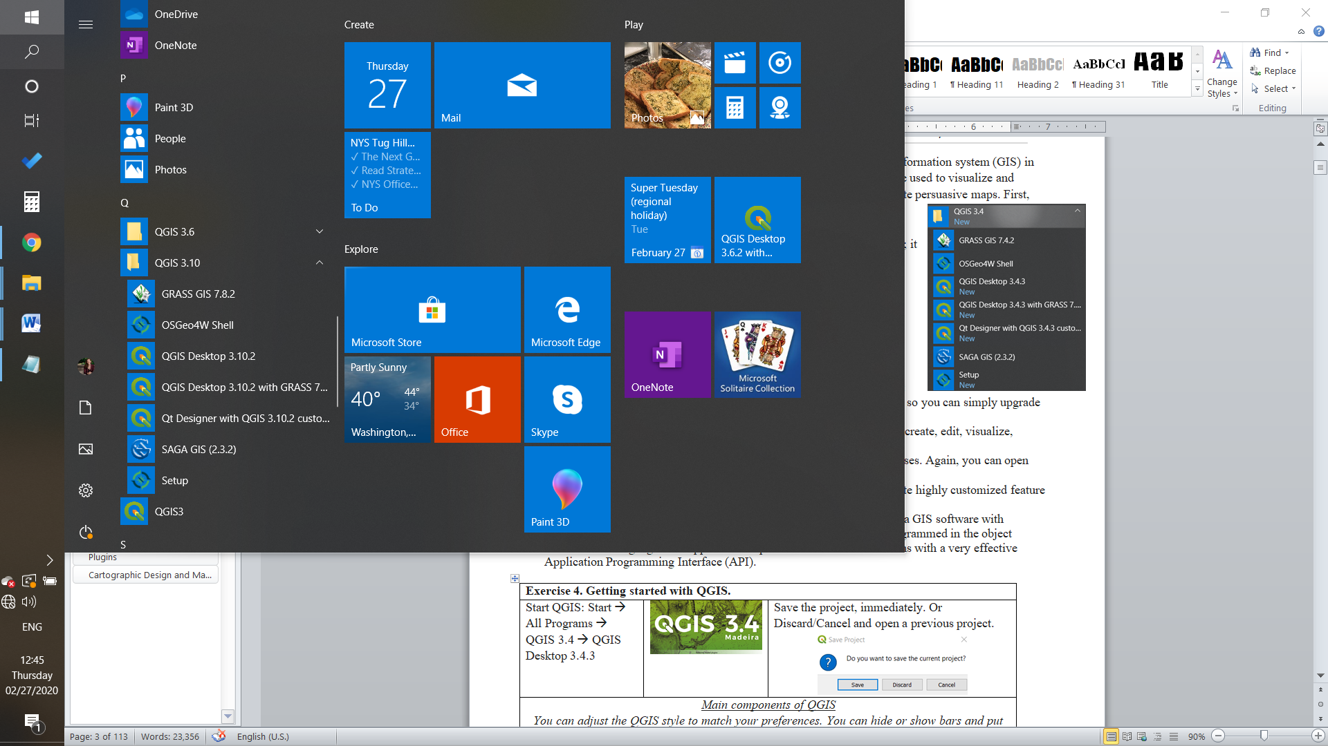GRASS GIS – (Geographic Resources Analysis Support System) is free; it is used for geospatial data management and analysis, image processing, production of maps and graphics, spatial modeling, and other visualizations. It can be used as a stand-alone program or directly in QGIS by opening “QGIS Desktop 3.10.2 with GRASS 7.8.2”
* OSGeo4W Shell – d
* QGIS – (previously, Quantum Geographic Information System) is free; it is used to create, edit, visualize, analyze, and publish geospatial information.
  + Desktop – Start new projects, edit data, perform geospatial analyses. Again, you can open Desktop with GRASS for more analysis options.
* Qt Designer – to create QGIS plugins’ interface dialogs, but also to create highly customized feature forms for editing vector layers’ attributes in QGIS projects.
* SAGA GIS (2.3.2) – (System for Automated Geoscientific Analyses) is a GIS software with immense capabilities for geodata processing and analysis. SAGA is programmed in the object oriented C++ language and supports the implementation of new functions with a very effective Application Programming Interface (API).
* Setup – a windows installer for Open Source GIS project that tracks different open source software and notifies you of newer versions so you can simply upgrade programs.

|  |  |  |
| --- | --- | --- |
| Exercise 1. Getting started with QGIS. | | |
| Start QGIS: Start 🡪 (Type or search) 🡪 QGIS 3.10 🡪 QGIS Desktop 3.10.2 | |  |
| *Main components of QGIS* | | |
| Main bar with drop-down menus | Where you can open files, save the project, access vector processing tools, raster processing tools, settings, configuration and many other things! | |
| Layers panel | This panel is where all the geospatial data that you have added to the project appears. You can activate or deactivate layers by clicking the square to the left of the layer. An X will appear or disappear. | |
| Browser panel | This panel allows for navigating to the folders where your data is stored. | |
| Map space | This is where your data is visualized. | |
| Main tools/functions | These are the tools that you have activated for ease-of-access. By right clicking in any of the grey space you can activate or deactivate functions and tools, which add or removes them from this grey space. | |

**0**

**Map space**

**Main tools/functions**

**(1) Start a new mapping project**

**(2) Choose a previous mapping project**

**Main drop-down menus**

**Layers**

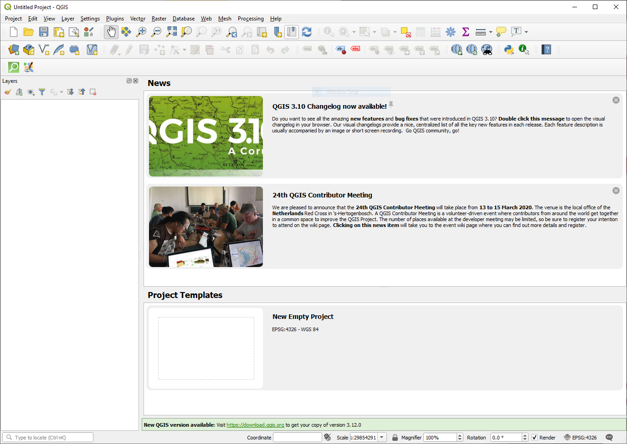

**Scale and coordinates**

**Coordinate reference system**

|  |  |
| --- | --- |
| In QGIS, set the project coordinate reference system to WGS 84 / UTM Zone 18N, which has the code 32618. This interface can be found on the bottom bar under the map space. It will say EPSG, which represents its spatial reference system identifier. | **↓**    **↓** |
| Start a new empty project by clicking on the blank map space/New Empty Project widget. |  |
| Save the project, immediately, so as to avoid losing any progress on your mapping project. |  |
| You can adjust the QGIS interface to match your preferences. You can hide or show bars/panels and arrange them anywhere. Right click on the gray part to open the list of toolbars and panels. You can check and uncheck different panels or toolbars to see what they look like in the interface. Note that your panels and toolbars options may differ from those shown in this manual. Before moving on, make sure that the “Browser Panel” and “Layers Panel” are checked and active. |  |

*What is spatial data?*

Spatial data, also known as geospatial data, is information about a physical object that can be represented by numerical values in a coordinate system.

*What is research data management or a data management plan[1]?*

Research data management (RDM) or data management plans (DMPs) are processes that describe how data will be collected, described, documented, shared, and preserved as part of a project.

Data Visualization Vector and Raster Data Models

Vector and Raster Data Models

**Vector data** is often created using a global positioning system (GPS), by interpreting imagery, or running analysis on existing vector data. The data can be represented as a point, line or a polygon.

*For instance:*

|  |  |
| --- | --- |
|  | **A point represents a fixed coordinate such as an individual building, an individual tree location, or a centroid of an individual place.** |
|  | A line is a series of points that are connected, but open at two ends. It could represent a road, river, hiking/biking path, division between one region and another, etc. |
|  | **A polygon is also a series of points that are connected, but are closed to create a shape. It could be an administrative unit, like an oblast, or parcel data, or an aggregated area or region.** |

Vector data is often stored as a shapefile (.SHP). However, as you can see in the following list, there are many other file types that QGIS can visualize, such as the KML (keyhole markup language) which is commonly used in Google Earth/Pro.

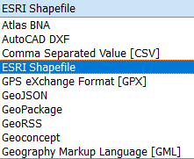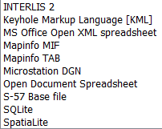

**Raster data** appears as an image composed of cells. The data is stored as cells in rows and columns with a unique value representing a geographic phenomenon. The larger the cells the lower the resolution of the raster image.

*For instance:*

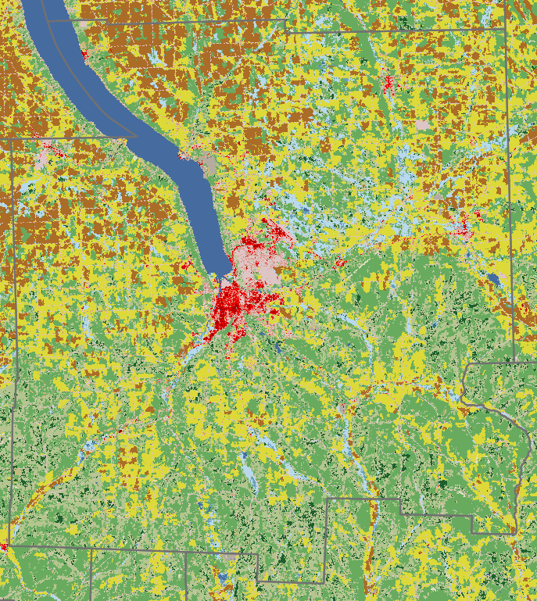

The most common raster data format is GeoTIFF. However, there are other formats that accepted in QGIS:

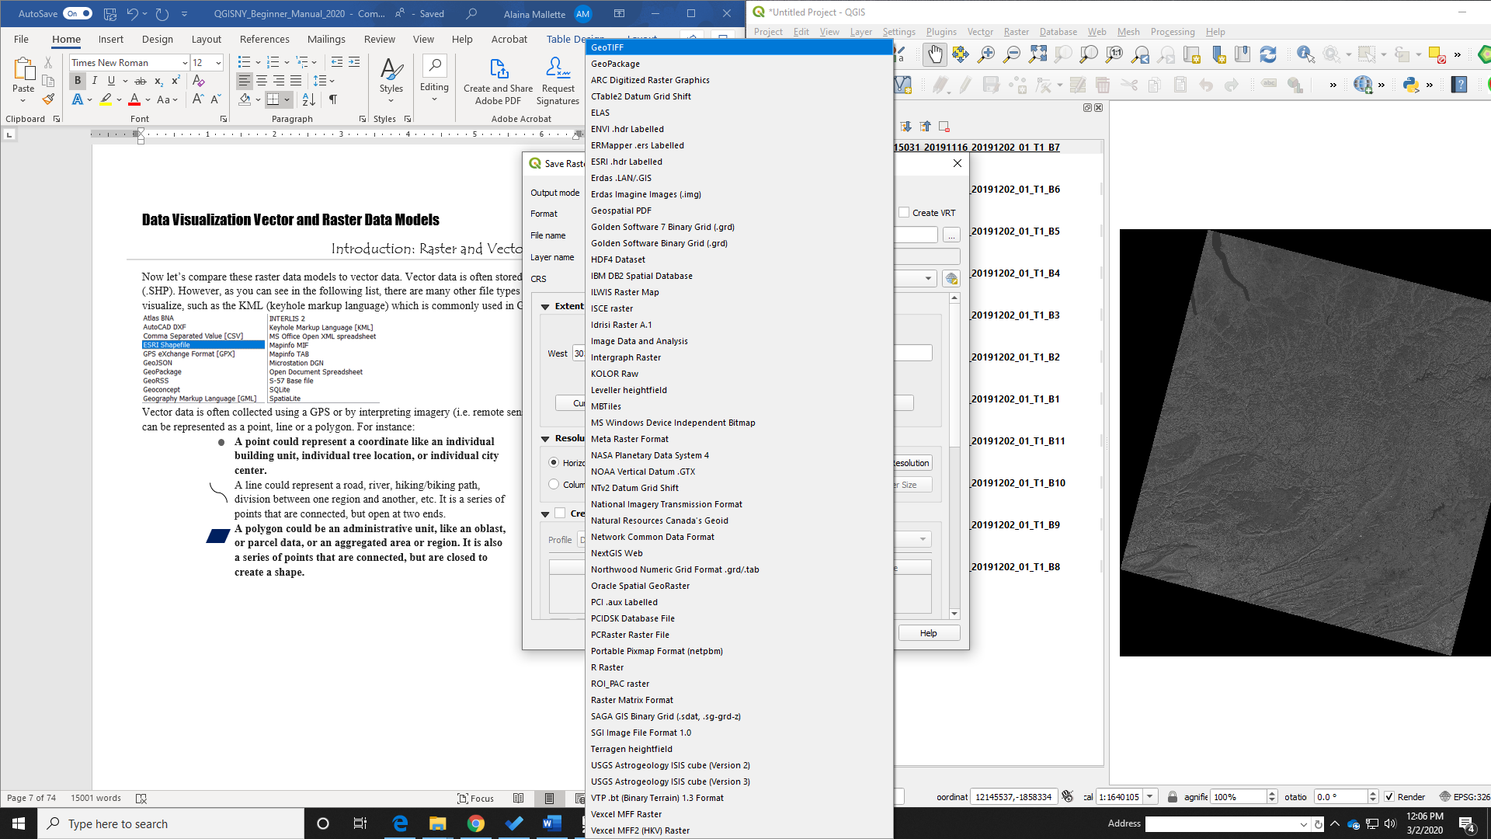 

Vector data models

In this next exercise, we will look at the points, lines, and polygons of the New York State region.

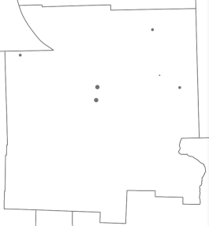 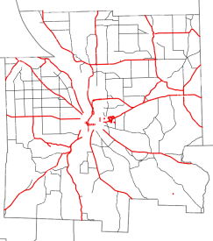 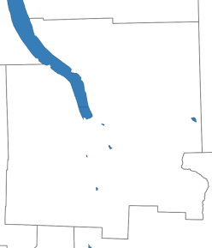 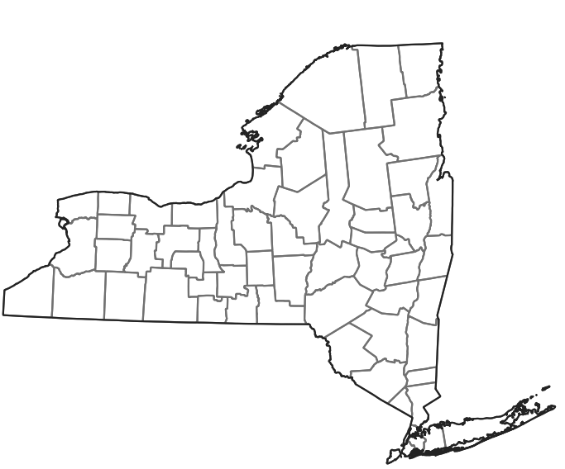 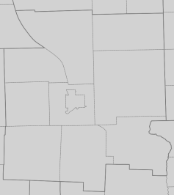

*Villages Roads Lakes County Towns, Cities*

|  |  |
| --- | --- |
| Exercise 2. Vector data models. | |
| Village  We will add vector data to the interface to see what land use data looks like as a point shapefile. Locate “NYS_Villages.shp” in your data folder in the browser panel. Drag it into the map space to add to the layers panel. |  |
| Roads  We will add vector data to the interface to see what land use data looks like as lines. View the manage layers toolbar (seen to the right), and click on the “Add Vector Layer” tool or “ctrl + shift + v”. Locate “NYS_Roadways_2018.shp” in your data folder. |  |
| Lakes  We will add vector data to the interface to see what land use data looks like as polygons. Locate “NYS_Lakes_2017.shp” in your data folder. Drag it into the map space to add to the layers panel. |  |
| Counties, Towns/Cities, NYS Shoreline  We will add two other vector data to the interface to see what land use data looks like as polygons. Using your preferred method, add “NYS_Counties.shp”, “NYS_Cities_Towns.shp”, and “NYS_Shoreline.shp” to the layers panel. | |
| In the layers panel, locate the new datasets. You can group the datasets into a toggleable category using the "Add Group" tool.  Tool icon:    In the map space, locate the datasets. |  |
| You can toggle the layers on and off to see the difference in geometry (i.e. points, lines, and polygons). The layers are organized like a stack of paper. What is on top is visual priority and “covers” the layers below. So, it is usually best to place point data on top, followed by line data, and lastly polygon data. Drag and drop to move layers up and down. | |

Raster data models

Let’s compare these vector models to raster data. As mentioned previously, raster data is stored in a series of columns and rows that create a grid of cells; each cell with a unique value that represents some spatial phenomenon. Raster images are important data sources and serve for many types of analyses in the areas of environmental science, natural resource management, and land development. They provide us with both current and historical information. Since the inherent structure of images is the same as raster models in GIS, the integration of these two technologies is quite common. Look at these two articles that show how satellite images can be used to map natural disasters: See Inside [Typhoon Mangkhut in 3-D](https://www.nytimes.com/interactive/2018/09/15/world/asia/super-typhoon-mangkhut-ompong-storm.html?emc=edit_nn_20180917&nl=morning-briefing&nlid=6798104020180917&te=1) and [Indonesia Earthquake and Tsunami: Before and After Photos of the Destruction](https://www.nytimes.com/interactive/2018/10/01/world/asia/map-tsunami-indonesia.html?emc=edit_nn_20181002&nl=morning-briefing&nlid=6798104020181002&te=1). Common datasets that appear in raster format are land use/land cover, digital elevation models, and satellite imagery. We will focus on land use/land cover data, digital elevation models, and orthoimagery for these exercises.

|  |  |
| --- | --- |
|  | The U.S. Geological Survey (USGS), in partnership with several federal agencies, has developed and released four National Land Cover Database (NLCD) products over the past two decades: NLCD 1992, 2001, 2006, and 2011. These products provide spatially explicit and reliable information on the Nation’s land cover and land cover change. To continue the legacy of NLCD and further establish a long-term monitoring capability for the Nation’s land resources, the USGS designed a new generation of NLCD products named NLCD 2016. The NLCD 2016 design provides innovative, consistent, and robust methodologies for production of a multi-temporal land cover and land cover change database from 2001 to 2016 at 2–3-year intervals. |
|  | Access to high-resolution imagery is provided by the NYSDOP’s orthoimagery (the program's goal is to obtain imagery for the entire State on a [4 to 5 year cycle](http://gis.ny.gov/gateway/orthoprogram/lotyrs.html)) or orthomosaics provided by drone coverage. This digital Orthoimagery can serve a variety of purposes, from general planning to field reference for spatial analysis to a tool for revision of vector maps. It can also serve as a reference layer (i.e., basemap) for GIS. It is also important to think critically about the date of a satellite image. The interpretation of a January image can differ greatly from a July image considering that January is wintertime and most vegetation and agriculture are in a state of rest in New York State. For example, images from the summer months can show net primary production, crop yields, and vegetation growth better than images from winter months. |
|  | The Digital Natural Color aerial imagery was acquired in May 2018 using a Microsoft Ultracam Eagle sensor flown at a nominal height of approximately 15,550 feet Above Mean Terrain. The Ground Control used to support the 4-band ortho-imagery production was collected by identifying and surveying photo identifiable points (PID), using existing PIDs, and existing aerial targets. The Digital Aerial Triangulation (DAT) was performed. Digital Surface Models (DSM) used for ortho imagery production were generated and updated as needed using UltraMap mapping software. |

**Q: How do satellite images work?** A: Sensors receive information about an object through electromagnetic energy. This information can be coded in the frequency, intensity or polarization of the wave and is transmitted directly from the object or indirectly by reflection, dispersion or re-emission to the sensor. All materials on Earth reflect or emit electromagnetic energy. The sensors measure the intensity of the electromagnetic radiation emitted by an object and study its physical properties and variation in frequency from other objects. In this exercise, you will practice *remote sensing* techniques and methods to improve the contrast of images, a process called *image enhancement*.

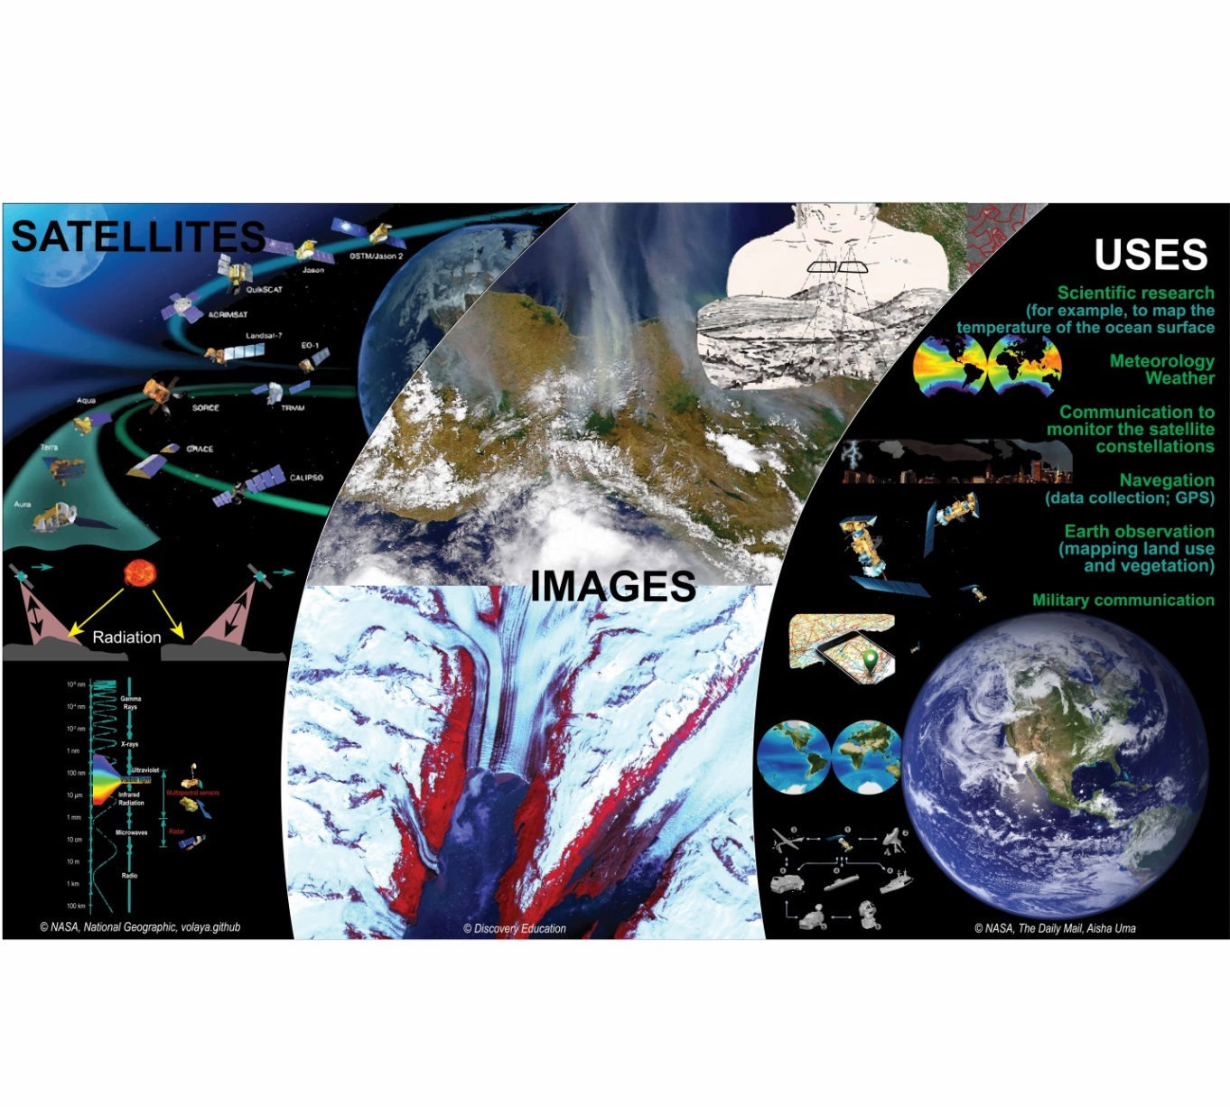

**Q: What is image resolution?**

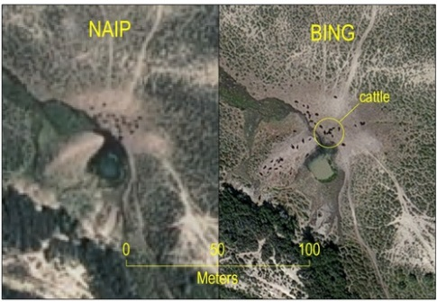A: The image to the left compares the same place with two images that have different resolutions. The image on the right has a higher resolution (30 centimeter) than the image on the left (1 meter). It is easier to interpret land uses when you have a high-resolution image. Many images with free access have a resolution of 30 meters, low resolution. Note that if two images—with the same extent—where compared, the image with higher resolution would contain more data.

*Figure 4. Image resolution of the same location. Source: [Bing Imagery](http://www.timassal.com/?tag=naip-imagery)*

All digital technology for visualization (monitors, printers, plotters, digital cameras, etc.) mix up a maximum of three individual color channels together: Red, Green, and Blue (RGB) for monitors and cameras; or Cyan, Magenta, Yellow, Keyline/black (CMYK) for printers. Each of the bands has a maximum of 256 intensity levels to create a combined color image. In other words, the combination of bands can provide different visualizations.

|  |  |
| --- | --- |
| Exercise 3. Raster Data Models. | |
| Open Raster options located in Settings🡪Options…🡪Rendering🡪  Rasters    And, change the algorithm for single-band gray and multi-band color to “Stretch to MinMax”. This will give you a better contrast on the raster images. |  |
| Now, using the Add Raster Layer button or by dragging the files from the Browser Panel, add the 2016 NLCD data, “NLCD_2016_Land_ Cover_L48_20190424.img”,to the Layers Panel or Map Space in QGIS. You will notice that the image is already stylized by land use/land cover. |  |
| Look in the layers panel to find the new image and expand its contents to see what color corresponds to each value. To better understand the classification values, review the metadata for this image file. The metadata is in XML format, which can easily be viewed in any web browser as a decision tree. |  |
| Add the individual orthoimagery tiles for Cornell University to the map space. Do so by selecting ONLY the raster image files (look for the raster tile symbol). |  |
| There is a second option for downloading a basemap of orthoimagery for the entire state, called a Web Map Service (WMS), located [here](https://gis.ny.gov/gateway/mg/webserv/webserv.html). Note that this requires an internet connection.    Follow these steps to include a WMS into your project:   1. Copy the WMS link on the gis.ny.gov website. 2. Open the WMS manager 3. Give the WMS a unique name and paste the URL. Click “OK”. 4. Select the unique name from your list of WMS and click “Connect”. 5. Highlight “O” to get all of NYS. Click “Add”. |  |

Layer Properties

Introduction

Every layer will have properties. Properties describe the layer and can be configured to fit your unique project needs.

|  |  |  |
| --- | --- | --- |
| The [layer properties for vector data](https://docs.qgis.org/3.10/en/docs/user_manual/working_with_vector/vector_properties.html#information-properties) includes: | | While the [layer properties for raster data](https://docs.qgis.org/3.10/en/docs/user_manual/working_with_raster/raster_properties.html#symbology-properties) includes: |
| 1. Information 2. Source 3. Symbology 4. Labels 5. Diagrams 6. 3D view 7. Fields 8. Attributes form 9. Joins 10. Auxiliary storage | 1. Actions 2. Display 3. Rendering 4. Variables 5. Metadata 6. Dependencies 7. Legend 8. QGIS server 9. Digitizing | 1. Information 2. Source 3. Symbology 4. Transparency 5. Histogram 6. Rendering 7. Pyramids 8. Metadata 9. Legend 10. QGIS server |

The layer properties that are frequently used are: information, source, symbology, labels (for vector data), transparency (for raster data), and metadata. **Information properties** is read-only and allows the user to review summarized information and metadata about the layer, including storage location, geometry type, and coordinate reference system—to name a few. **Source properties** has the layer name, encoding information, and the coordinate reference system. If the coordinate reference system that is selected is incorrect or if none was applied, then you can use the drop-down list to select a recent coordinate reference system or slick the “Select CRS” button to select a specific coordinate reference system that is not showing in the drop-down list. If you need to reproject a layer, do not do so in source properties. There are specific algorithms for doing so in the processing toolbox, which will be discussed later, or you can right-click on the layer “Export” and “Save Feature As…” a new layer with the new coordinate reference system.

**Symbology properties** allows you to change the aesthetics of your layer. When you add a layer to your project, a color scheme is usually automatically applied. For vector data you can switch from a single symbol to a categorized, graduated, rule-based, and a few other options based on the type of data you are mapping. These new styles can be saved. Raster data symbology properties include multiband color, paletted values, singleband gray or pseudocolor, and hillshade, Again, the proper symbology will depend on what you intend to visualize.

**Label properties** are only available for vector geometries and are useful for wayfinding in a map. **Transparency properties**, on the other hand, are only available for raster data and allow the user to use a slider to change how visible underlying layers are through the raster layer. The previous page described what metadata is, and the **metadata properties** is where you can create and edit the layer’s metadata.

Metadata

**Metadata** will vary depending on the standard you use. For instance, the DCMI developed standards has identified fifteen (15) properties that must be included in final metadata:

1. Contributor: An entity responsible for making contributions to the resource. Examples of a Contributor include a person, an organization, or a service.

2. Coverage: The spatial or temporal topic of the resource, the spatial applicability of the resource, or the jurisdiction under which the resource is relevant. Spatial topic and spatial applicability may be a named place or a location specified by its geographic coordinates. Temporal topic may be a named period, date, or date range. A jurisdiction may be a named administrative entity or a geographic place to which the resource applies. Where appropriate, named places or time periods can be used in preference to numeric identifiers such as sets of coordinates or date ranges.

3. Creator: An entity primarily responsible for making the resource. Examples of a Creator include a person, an organization, or a service.

4. Date: A point or period of time associated with an event in the lifecycle of the resource.

5. Description: An account of the resource. Description may include but is not limited to: an abstract, a table of contents, a graphical representation, or a free-text account of the resource.

6. Format: The file format, physical medium, or dimensions of the resource. Examples of dimensions include size and duration.

7. Identifier: An unambiguous reference to the resource within a given context. Recommended best practice is to identify the resource by means of a string conforming to a formal identification system.

8. Language: A language of the resource.

9. Publisher: An entity responsible for making the resource available. Examples of a Publisher include a person, an organization, or a service. Typically, the name of a Publisher should be used to indicate the entity.

10. Relation: A related resource.

11. Rights: Information about rights held in and over the resource. Typically, rights information includes a statement about various property rights associated with the resource, including intellectual property rights

12. Source: A related resource from which the described resource is derived.

13. Subject: The topic of the resource. Typically, the subject will be represented using keywords, key phrases, or classification codes.

14. Title: A name given to the resource.

15. Type: The nature or genre of the resource.

*What are metadata?*

Metadata is “data about the data,” or information that describes the content, quality, condition, origin, and other data characteristics so that it can be understood, reused, and integrated into other datasets. Metadata are ESSENTIAL for any use or reuse of data; no one can responsibly reuse or interpret data without metadata that explains how the dataset was created, why, where it is geographically located, and details about its structure. In general, they answer the following questions:

* **What** does it represent? What data model (raster, vector) does it use?
* **How** was the data created? Including what software or technology was used.
* **When** was the data created?
* **Where** was it collected?
* **Why** was it collected?
* **Who** created it?

Important information that you should include for more responsible reuse and interpretation of the data are: the availability and distribution of the information, its original projection and datum, the scale, the resolution, the properties, the attributes, etc.

Metadata are used for enabling data discovery, understanding data, analysis, maintaining longevity of a dataset, and tracking the progress of a research project. It is easier today to get spatial information than ever before and authors of GIS data can share useful information to the user who will reuse or interpret the original data. Users can use the metadata to locate other data sources, read a description of how the data should be interpreted, and responsibly share the data with others.

In the US, federal agencies are mandated by an executive order to use metadata standards endorsed by the [Federal Geographic Data Committee (FGDC)](https://www.fgdc.gov/metadata/), which are 1) the Content Standard for Digital Geospatial Metadata or its extensions for biological and shoreline data and 2) International Organization for Standardization (ISO) series of standards (19115, 19115-2, 19139, etc.). There is an ongoing effort to move towards adopting the ISO metadata standard. In each of these standards, metadata must be formatted in extensible markup language (XML). For styling, a stylesheet can be applied over the XML to make it more legible to the average user. In Europe, the Dublin Core Metadata Initiative[2] (DCMI) metadata standards is commonly used.

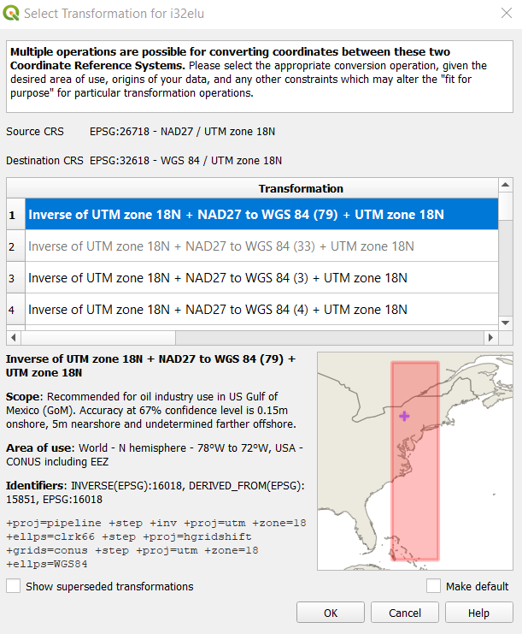

T dfd

Note: If you ever receive this “Select Transformation” prompt for the layer that you are adding, then the layer’s coordinate reference system does not match the coordinate reference system of your project. In this example, you see that the digital elevation model’s source coordinate reference system is NAD27 (North American Datum 1927) / UTM (Universal Transverse Mercator) zone 18N. The projected system is the same, but the datum is not. The project and the other data sets are using WGS 1984 (World Geodetic System).

The transformation function will allow the software to convert the coordinate from NAD27 / UTM zone 18N to WGS84 / UTM 18N. You can select the first recommended transformation or scroll through the list to see what best suits your purposes. The scope description will give you a good idea about the original purpose of the coordinate reference system, and sometimes the extent of the coordinate reference system. When in doubt, you can look at the map with the red box, which shows the area meant to be served by the coordinate reference system.

|  |  |  |
| --- | --- | --- |
| Exercise 4. Symbology, labels, and transparency. | | |
| Each layer has a box with an “☑” If you do not want to see the layer, click on the box and it is hidden from view. The layer is NOT removed from the project. Simply, you have to click again to make it appear. To remove something, right-click and select “Remove”. | | |
| **Save your project, and save often! Sometimes QGIS will shut down if it is overloaded. So, do not get stuck having to start over on a project**, especially if you have been working on it for hours. |  | |
| Each layer has specific properties. In this exercise you will edit the symbology/style. To access the properties of the layer, double-click on the name of the layer or right-click and navigate to Properties. Click on Symbology.  You can also access this properties interface through the layers panel. Select the styling panel window or click F7 to open the styling panel. |  | |
| *Changing symbology of points, lines, and polygons.* | | |
| Villages  Open Layer Properties (double-click on layer or right-click🡪Properties). For point data, you can change the marker type (symbol layer type), size of point, fill and stroke colors, stroke style and width. If you click on “Simple marker” you can make more detailed changes. You can save symbol styles using the “Save Symbol…” button. |  |
| There is second approach to changing the layer styling, it is one of the Layers icons: “Open the Layer Styling Panel”. This can also be quickly accessed using [f7]. The Layer Styling panel will appear on the right-hand side of the interface. You can move it to any edge of the screen. |  |
| There is a field in the layer’s attribute table that represents 2010 population numbers. This information can be visualized as graduated symbols. Return to the Village layer’s symbology properties. | |
| At the top of the interface where it says “Single Symbol”, click the drop-down menu and select “Graduated”. Next, Value represents the attribute that you wish to display, visually. In this case, we will use POP2010, the U.S. 2010 Census total population count. You can change the style of the symbol and the color prior to classifying the ranges. Note that the legend format is NOT in percentages, rather as-is numerals.  We will be graduating the village layer’s points by size, between 1 milimeter and 3 milimeters. The classes, or ranges, can be divided depending on how the data is distributed, which you can review in the “Histogram” tab.  Returning to the classes tab, you will notice that you can select a statistical “mode” for dividing up your ranges. These modes use different statistical algorithms to break down the data into separate classes. You can try different methods. The more appropriate method will depend on your data and project goals. When you decide, you click “Classify”.  For this exercise, select only 3 classes for the Equal Count (Quantile) mode. Manually, you can change the size of each symbol so that the smallest range (i.e. class) is 1 point in size, the middle range is 2 point, and the largest value range is 3 point. You can keep the color ramp colors or select the same color for each ranges symbol by double-clicking on the symbol in the classify list to change the fill, stroke, and add any special fills. | * **Equal Count (Quantile)** - This method will decide the classes so that the number of values in each class are the same. If there are 100 values and we want 4 classes, quantile method will decide the classes such that each class will have 25 values. * **Equal Interval -** As the name suggests, this method will will create classes which are at the same size. If our data ranges from 0-100 and we want 10 classes, this method would create a class from 0-10, 10-20, 20-30 and so on , keeping each class the same size of 10 units. * **Logarithmic scale** - A logarithmic scale is a nonlinear scale used for a large range of positive multiples of some quantity. It is based on orders of magnitude, rather than a standard linear scale, so the value represented by each equidistant mark on the scale is the value at the previous mark multiplied by a constant. * **Natural Breaks (Jenks)** - This algorithm tries to find natural groupings of data to create classes. The resulting classes will be such that there will be maximum variance between individual classes and least variance within each class. * **Pretty Breaks** - This is based on the statistical package R’s pretty algorithm. It is a bit complex, but the pretty in the name means it creates class boundaries that are round numbers. * **Standard Deviation** - This method will calculate the mean of the data, and create classes based on standard deviation from the mean. |
| Roadways  Open Layer Styling. For line data, you can select an automatic design style under “Favorites” or select “All Symbols” to see a wider variety of options. |  |
| There is a field in the layer’s attribute table that represents the road jurisdiction as federal, state, county, local, or another jurisdiction. This information can be visualized as categorized symbols. Return to the Roadways layer’s symbology properties.  In the drop-down menu where you see “Simple Line”, select “Categorized”. The attribute, or “Value” in this case, that represents jurisdiction of roadways is “Jurisdicti”. Select that “Value” and “Classify”.  Merge the jurisdictions that relate to the state and color the symbol red. Merge (right-click and select “Merge categories”) all local jursidictions into one local agencies symbol, color it white. Make army roadways a red dashed line and county roadways black. Any private roads can be yellow. Change the width of your lines as desired.  Sometimes there are values or non-values that you want to delete, which can be done by selecting the value/row and clicking the red minus button. | Jurisdictions in Tompkins County:   * 01 NYSDOT * 02 County * 03 Town * 04 City or village * 11 State Parks * 21 Other State agencies * 25 Other local agencies * 26 Private or Restricted Access * 74 Army |
| Lakes  Open Layer Properties (double-click or right-click🡪Properties). For polygon data, you can also change the design style to a predefined “Favorite” or generic symbol. Of course, you can simply change the color of the symbol. |  |
| Counties, Cities/Town, and NYS Shoreline  For each of the three layers, open Layer Properties (double-click or right-click🡪Properties) and edit the style as you see fit. **Note**: Make the interior of a polygon transparent by clicking its “Simple fill” and changing the fill color (drop-down) to transparent fill.  As with points and lines, polygon data can also be changed to “Categorized” or “Graduated” in order to create colorful ranges for attribute variables, such as choropleth maps. To learn more about appropriate color schemes, go to [COLORBREWER 2.0](http://colorbrewer2.org/#type=sequential&scheme=BuGn&n=3) for color advice. |  |
| We are going to create a graduated, choropleth map of the percent of population change by county between 1990 and 2010.  1. Select “Graduated”  2. Select the expression icon to calculate population change:    3. Change the legend format so the legend will be a percent with a precision of 0 to eliminate decimal places.  4. Choose the red to blue color ramp.  5. Click “Natural Breaks (Jenks)” mode and “Classify” into 5 ranges.  6. Apply changes to the layer. |  |
| You can add labels to your map. In Layer Styling for NYS_Counties, change “No labels” to “Single labels” for the attribute with NAME values for each county. You can change the font, font size, color, etc. You can even add a buffer around the text.    You can edit the label placement for every label using Placement tab: |  |

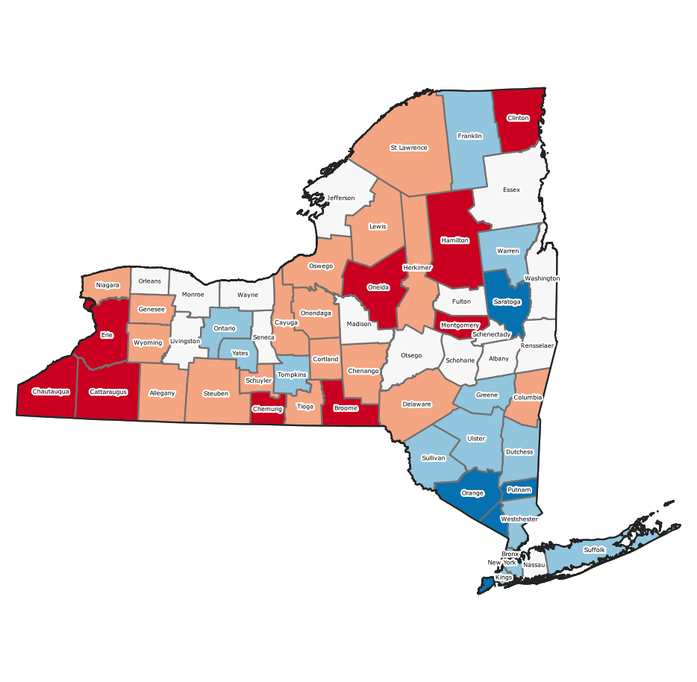

|  |  |  |
| --- | --- | --- |
| *Changing symbology of raster data* | | |
| Change render type to pseudocolor, change the color ramp and make sure that you have 6 classes.      However, the colors represented normally have nothing to do with land use or forestry. Thus, double-click the color to choose a new one. | | You can add labels, as well, by clicking on the number that appears under label and writing in the land use. |
| In the next tab, Transparency, you can add transparency to see images and spatial features behind the dataset. | |  |
| If you click Apply, you will remain in the Properties interface. If you click OK, the interface will close. | |  |
| With any new dataset that you will be using, it is a best management practice to review its metadata prior to adding it to QGIS. We will add the Sentinel-2 image to QGIS, so we should review its acquisition date, datum, projection, resolution, and units. | |  |
| Now your data is in QGIS, but you have to verify the placement and results. We will superimpose the original Sentinel-2 image. Download the file from the Google Drive folder (TARTAR_2A_151018) or USB. | |  |
| Remove the files from this folder and save them in your main database and again in your permanent folder for the course, the same one you used to save the ASCII data. | |  |
| Back in QGIS Desktop with the Browser Panel, look for the file “TARTAR_S2A_151018.tif” in the folder for the workshop. Sometimes, you have to update the list of connections. Drag the image to the list of layers or the map space; make sure it is below the other layers. | |  |
|  | | |
| There are five standard options to change the style (i.e., “Render Type”) of a raster layer:  i. *Multi-band color* (Typical for classifying satellite images, such as LANDSAT)  ii. *Paletted*, where a color is chosen for each unique value  iii. *Singleband gray*, where only gray-scale is considered  iv. *Singleband pseudocolor*, where a scale can be chosen with different hues  v. *Hillshade*, for elevation rasters | | |
| Now, let’s open the properties for the percent agriculture and change the symbology. For this data, there are eleven (11) categories for agriculture (values 0-10); the appropriate option would be "Singleband pseudocolor." Choose the red-to-blue color ramp.  and then “Invert Color Ramp” to have “0” represented by blue and “10” red represented by red as a danger to the health of limans. In addition, you can add a unique label for each value. Add a label unit suffix (%) or double-click on the label of each value and write the appropriate labels. You can also do this in the layers panel.  Add the 50% transparency to see the Sentinel-2a image below. |  | |

Picture

Basic Tools: Pan Map, Zooming, and Measurement Tool

Introduction

There are many panels and toolbars on your main screen that you can view or hide from view, including the layers panel, map navigation toolbar, and attributes toolbar. It is recommended that you familiarize yourself with these icons and tools as they are commonly used in projects. The following tools are used for map navigation.

|  |  |  |  |
| --- | --- | --- | --- |
| Icon | Description | Icon | Description |
|  | Pan: Click and drag to move within the map space to find your area of interest. This can also be done with the space bar and a mouse. |  | Zoom to native resolution (raster layer) |
|  | Pan map to selection: Pans to selected features, but does not zoom into the features. |  | Zoom last: Returned to previous zoom extent, like a zoom undo. |
|  | Zoom-in: Focus on features at a larger scale, i.e., closer to 1:1 scale. A mouse wheel scrolled upwards will also zoom-in. |  | Zoom next: Return to most recent zoom, like a zoom repeat. |
|  | Zoom-out: Focus on features at a smaller scale, i.e., further away. A mouse wheel scrolled downwards will also zoon-out. |  | New map view: Opens a new map screen to pan and zoom, separately from the main map space. |
|  | Zoom full: Zooms to the full extent of all data layers. |  | New spatial bookmark: Create a spatial bookmark for the user or the project, or a saved geographic location to return to quickly. |
|  | Zoom to selection (vector): When there are features selected, this tool will pan and zoom to only those selected features. |  | Show spatial bookmarks: The saved bookmarks will appear in your browser panel. |
|  | Zoom to layer: Zooms to highlighted layer in layer panel. |  | Refresh: Map canvas and layers update, especially useful after adding a layer, panning or zooming, resizing the window, or changing visibility of a layer |

It is important to understand the attributes for each of your layers. The attributes toolbar will help you familiarize yourself with the attribute information. It also includes a simple tool for calculating lines, areas, and angles: the measurement tool. Most select features tools will be covered in the section on spatial and non-spatial data queries.

|  |  |  |  |
| --- | --- | --- | --- |
| Icon | Description | Icon | Description |
|  | Identify features |  | Toolbox |
|  | Select features |  | Show statistical summary |
|  | Select features by polygon |  | Measure line |
|  | Select features by freehand |  | Measure area |
|  | Select features by radius |  | Measure angle |
|  | Select features by expression |  | Show map tips |
|  | Select features by value |  | Text annotation |
|  | Select all features |  | Form annotation |
|  | Invert feature selection |  | HTML annotation |
|  | Deselect features from all layers |  | SVG annotation |
|  | Open attribute table |  | Move annotation |
|  | Open field calculator |  |  |

The following exercise will highlight a few of the tools listed in the previous tables.

|  |  |
| --- | --- |
| Exercise 5: Map navigation and attributes toolbar | |
| *Map navigation* | |
| Pan to a different part of the map. | |
| Zoom to the full extent of the data. |  |
| Select and highlight the layer for Tompkins County roadways. Then, click on the zoom to layer icon. You can also right-click and select “ |  |
| Click on the zoom last icon to return to the zoom view of New York State. | |
| *Measuring* | |
| The interactive measure tool allows for measuring the horizontal distance in the map space. The calculations are made based on the coordinate system for the project. |  |
| You can change the units, start a new measurement, configure the settings, close an accidental click, or ask for help to open QGIS Help function. Calculations can be made with ellipsoidal (default) or cartesian math, which is used for projected and planimetric area or distance. |  |
| With the measurement tool, you can also measure area. Just like with the measurement line tool, you can change the units from square kilometers to hectares or any other unit that you are analyzing. “New” button allows you to start a new measurement. According to the NYS Department of Health, the state of New York covers 47,214 square miles (122,284 km2), so you can see that this quick measurement was slightly higher. |  |

Attribute Table and Table Management

Introduction

Aa

* [toggleEditing](https://docs.qgis.org/3.10/en/_images/mActionToggleEditing.png) to indicate that the layer is in edit mode and you can modify the data
* [editableEdits](https://docs.qgis.org/3.10/en/_images/mIconEditableEdits.png) to indicate that the layer being edited has some unsaved changes

|  |  |
| --- | --- |
| Exercise 6. Editing attribute tables | |
| *Adding a new area field/attribute to polygon data* | |
| We will look at the total area in hectares of the water shapefile that we have. You may notice that this does not include the ocean as it is inland water bodies, which excludes oceans and seas. We will open the attribute table to create a new field for area in hectares. To do so, right-click and select Open Attribute Table. |  |
| There are four attributes: osm_id, code, fclass, and name. None of these attributes tells us about area in hectares. So, you will need to click the Open Field Calculator tool. |  |
| The field calculator is very useful and we will work with it more in future lessons. For now follow these steps to create an area field:   1. Make sure Create a new field is selected 2. Write AREA in Output field name 3. Select Decimal number (real) as the output field type 4. Output field length of 20 characters and 2 decimal places 5. Add the expression $area/10000 6. Click OK |  |
| Now you will notice five fields, since the new AREA field has been created. Since our projection is in meters, the map units are also in meters. For this reason, we divided the function $area by 10,000 since 10,000 m2 = 1 ha |  |
| You can order the column by highest to lowest simply by clicking the column title. |  |
| Click the column titles again and it will be ordered lowest to highest.  When you are done editing the field. Click on the Save edits button and turn the Toggle editing mode off |  |
| One of the two tools you can use to add up the sum of the area values is located in Vector🡪Analysis Tools🡪Basic Statistics for Fields… |  |
| Choose the input layer (TARTAR_ OSM_water_2018) and select the field that will be calculated (1.2 AREA). You can make the output HTML file temporary or permanent. The temporary files are stored in the temporary folder specified in QGIS configuration. The permanent file location is determined by you so that you can access the file again at a later date.  Click Run. A Results Viewer window will appear. Click on the File path link, and the HTML will open in your browser. You can also double-click on Σ Statistics [TIME]. |  |
| In the webpage, you will find all the statistical data for that field. Look for Sum and write down the answer to the sum of water polygon areas (ha) in the table in **Question 4**. |  |
| Now, we will try a different tool, rather a panel that provides quicker statistical analysis. Open the TARTAR _OSM_LandUse_2018 shapefile’s attribute table. Select the fields that represent agriculture, such as allotments and farm. To select, click on the number of the row use the ctrl key and select all fields.  Then, right click on the grey space around the main tools and functions bars, look for Statistics Panel in the list and activate it. |  |
| In the statistics panel, select the TARTAR_OSM_LandUse_2018 shapefile/layer and select the column for AREA. Before reading the statistics values, click the Selected features only box so that the statistics are only run on the selected agriculture polygons. Find Sum and write the area value (ha) in the table in **Question 4**. |  |

In the last exercises we learned how to create an expression (query) using SQL and to select features based on their spatial relationship. In this exercise, you will learn how to manipulate the attribute table. This is necessary when your dataset is extremely out-of-date or requires updated information. If any of your data is to be published, then you and your team are going to want very accurate data. One way to get updated information is through national, regional, and local publications that provide data at some geographic scale. For instance, the publication titled “Державна служба статистики України: Головне управління статистики у Рівненській області 2017”, provides relatively up-to-date statistical information for the Rivne oblast by city and district. The data provided by books can be saved in a separate Excel table to add to existing datasets. Also, field worksheets can be used to join to existing datasets. Pretty much any table in Excel, CSV, text and similar formats can be joined to attribute tables in existing geospatial data layers. Fortunately, there is a way to join the tables, which adds attribute data to existing spatial features using a *common identifier*.

For example, below you see two tables. The table on the right represents the attribute table within an existing shapefile. The table on the left represents the table to be joined to the existing geospatial layer. The field that they have in common is ISO and ISO2.

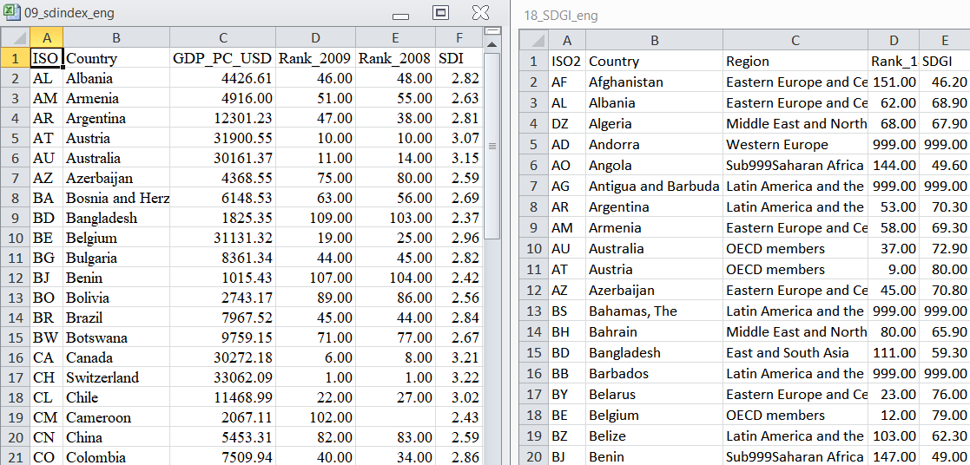

Review the file that you wish to merge to an existing dataset and find the common identifier.

Joining Tables

|  |  |  |
| --- | --- | --- |
| Exercise 7. Review attributes and join tables | | |
| *Review attributes and preparing the datasets* | | |
| Find the file that contains the table/spreadsheet that you wish to join to an existing dataset and drag it into your project. It will appear in the Layers Panel. |  | |
| Since it is considered a vector layer (non-raster) it will open a Select Vector Layers to Add… tool in which you choose with Excel spreadsheet in the file you want to add to the QGIS project. Click OK. |  | |
| Open the properties of existing shapefile. | ↓ | |
| In the Properties interface, you will find a section (tab) called Joins. It is 9th on the list. As you can see, there are no joined layers, so we must add a new one, using the green plus button .  In the Add Vector Join interface, the Join layer is the table file such as an XLSX file. The field that they share in common should be selected for Join field and Target field. Keep the cache the information into a virtual memory checked as default. If you do not want to join all fields, you can select which fields interest you in the Joined Fields section. By default, the software adds a prefix to the data fields so you remember that they are virtual (not permanent). To remove the prefix or add a different one, select “Custom Field Name Prefix” and edit it. Click OK.  The new join will appear in the joins list. |  | |
| Now in the Attributes Form tab, you will be able to see the joined attributes in the list of Fields.  They are all integer values. You will notice that the existing data is editable while the joined data is not. Click Apply and go to the attribute table. You will see all the attributes from the tabular file joined to the existing attribute table. |  | |
|  | | |
| If you want to create permanent fields out of the virtual joined data attributes, you can open the Field Calculator, “Create a new field” with a different name than the joined attribute name. Change the field type, length, and precision to match that of the original data. Find and select the joined field name in Fields and Values so that it appears in the expression. Click OK. Now in the attribute table you will have a permanent field for that attribute. | |  |

Spatial and Non-Spatial Data Queries

Introduction

One of the characteristics of GIS programs is that they have the ability to select spatial features of a layer based on the attributes or geographical location. When you have identified them, these objects can be (1) seen highlighted in the map, (2) be analyzed statistically (only for those selected features), and (3) saved as a new layer for viewing or further analysis. An essential GIS skill for any individual or institution is to understand and manipulate the layers according to their attributes and/or location using a specific language, known as a structured query language (SQL).

To demonstrate these concepts, this manual will use a global dataset for sustainable development indices provided by [BertelsmannStiftung and Sustainable Development Solutions Network](http://sdgindex.org/), a Global Initiative for the United Nations. It will look at a hypothetical “self-created” sustainable development index in 2009 and compare to the sustainable development goals index of 2018.

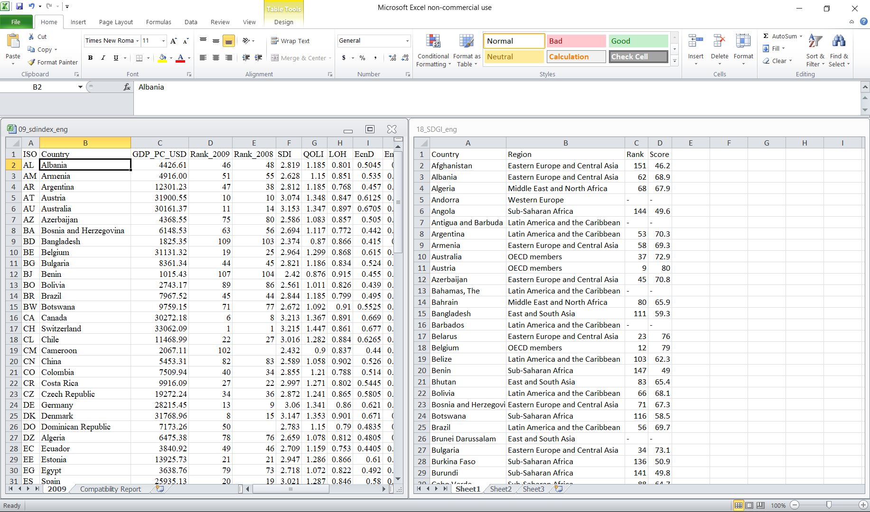

The “host” dataset for these tables will be country shapefiles downloaded from the [GADM (Global Administrative Areas) dataset](https://library.mcmaster.ca/maps/geospatial/global-administrative-areas-gadm), which was created in 2015 by the University of California, Berkeley, Museum of Vertebrate Zoology. The datum for this dataset is WGS 1984. Though the data is unprojected, it is represented in decimal degree units. The countries have polygon (e.g. area) geometry.

Non-spatial Data Queries

We will do simple, non-spatial queries to select specific data. Non-spatial structured queries are used when you want to filter features of a layer according to its characteristics, or *attributes*.



Let’s take for instance Vincent Van Gogh’s bowl of fruit, which has two pears, two apples, and one orange. These fruits have different attributes, such as color, size, taste, and type. A standard query language (SQL) can help us filter the fruits based on those attributes.

|  |  |  |  |  |
| --- | --- | --- | --- | --- |
| ID | TYPE | COLOR | SIZE | TASTE |
| 1 | Apple | Red | SMALL | Sweet |
| 2 | Apple | Red | MED | Sweet |
| 3 | Orange | Orange | SMALL | Citrusy |
| 4 | Pear | Green | LARGE | Sweet |
| 5 | Pear | Green | LARGE | Sweet |

If our question was, “How many fruit are red?”, then, the SQL expression would be:

**Simple**

“COLOR” = ‘Red’

The selection would highlight ID 1 and 2. This is a selection based on one attribute value.

If our question was, “How many fruit are red and small?”, then, the SQL expression would be:

**AND**

“COLOR” = ‘Red’ AND “SIZE” = ‘SMALL”

The selection would highlight ID 1. With Boolean AND, all the selected features must comply with ALL the requested attributes.

If our question was, “How many fruit are red or small?”, then, the SQL expression would be:

**OR**

“COLOR” = ‘Red’ OR “SIZE” = ‘SMALL”

The selection would highlight ID 1, 2, and 3. Contrary to Boolean AND, Boolean OR will select features that have ANY of the requested attributes.

If our question was, “How many fruit are not red?”, then, the SQL expression would be:

**NOT**

NOT (“COLOR” = ‘Red’)

The selection would highlight ID 3, 4, and 5. The selection must not have the attribute value.

If our question was, “How many fruit are citrusy?”, then, the SQL expression would be:

**LIKE**

“TASTE” LIKE ‘%Ci%”

The selection would highlight ID 3, since its attribute contains part of “Ci” (case sensitive).

If our question was, “How many fruit are citrusy?”, then, the SQL expression could also be:

**ILIKE**

“TASTE” ILIKE ‘%ci%”

The selection would highlight ID 3 again; since it contains the letters “ci” and it ILIKE is not case sensitive like LIKE.

|  |  |  |
| --- | --- | --- |
| Exercise 8. Non-spatial data query. | | |
| Review the attributes of your dataset. What information would you like to filter? If there is any incomplete datasets, you can complete them by editing by hand or by making special selections. | |  |
| You must activate the edit mode  in order to modify data values. Once active, change the values. Save the changes  and deactivate the edit mode . | |  |
| Find the Select by expression tool either in the main toolbar or in the attribute table. | |  |
|  | | |
| The space above is where the expression will go. Consider the different Boolean languages that are described in the introduction: simple, AND, OR, NOT, LIKE, and ILIKE. We will be using these operators to select information. There is a section in the middle which provides all the different inputs for your equation. For instance, the sub-section “Fields and Values” are the attributes in your attribute table. Double-click on the field you want to filter. It will appear in the expression. | | |
| So, you are able to select those attributes for your selection and specifically the values of that attribute that are of interest. You can see all the values per attribute (field), by clicking Load values “All Unique” button. The will appear in the black space in the last third of the tool. | |  |
|  | | |
| Your expression is incomplete if you can an output preview that says “Expression is invalid”. It should appear with a black number confirming validity. |  | |
| The Boolean operators explained previously are located in Operators in the center section, but can be typed in the expression, as well.  It is a good idea to use parenthesis when using several operators so as to not accidentally pair them. |  | |
| Once you are ready, click “Select”. |  | |
| The number of features selected can be found at the top of the attribute table and will be mentioned in the bottom ribbon of the main interface screen. | and | |
| Open the attribute table. In the bottom right, you will see that “Show All Features” is the default. Change this to “Show Selected Features”. The table will show only the features that fit your expression. |  | |
| In the map space, these features will appear selected in yellow compared to the main style color for the layer. |  | |

Spatial Data Queries

In a spatial data query the objects of a layer are selected according to their proximity or relative location to the objects of another layer. They are based on 1) all the features within a layer or 2) the features selected from a previous selection. Consider again our Van Gogh fruit case. Imagine that the fruit are one layer and the bowl is a second layer.

Case #1

We want to select all the fruit that are in the bowl. So, the layer that we want to have selected at the end is the fruit, or our *source features*. Our function would be *within* since we ONLY want the fruit that are within the limits of the bowl. The bowl is our *reference features* layer. When we *create a new selection*, the following features are selected:

* The apple in the bowl
* The orange in the bowl
* The first pear in the bowl
* The second pear in the bowl

Case #2

Remember our simple selection, “COLOR” = ‘Red’, which selected the two apples? We can create a new selection based on that selection. Imagine that the two apples are selected as our *source geometries* within the *source features*. If we added the spatial query for those selected features *within* the bowl layer, then our new selection would be:

* The apple in the bowl

|  |  |  |  |  |
| --- | --- | --- | --- | --- |
|  | **Input features to be selected** | | | |
| **Comparison features** |  | *Point* | *Line* | *Polygon* |
| *Point* | Equals, Intersects, Is disjoint, Overlaps | Contains, Intersects, Is disjoint | Contains, Intersects, Is disjoint |
| *Line* | Crosses, Intersects, Is disjoint, Touches, Within | Crosses, Equals, Intersects, Is disjoint, Overlaps, Touches | Contains, Intersects, Is disjoint |
| *Polygon* | Crosses, Intersects, Is disjoint, Touches, Within | Crosses, Intersects, Is disjoint, Touches, Within | Contains, Equals, Intersects, Is disjoint, Overlaps, Touches, Within |

The different relative relationships that exist for different geometries are as follows:

The main spatial relations between features for selection mentioned in the above table are:

* *Crosses* (only possible with line or polygon geometries, is when the source features crosses the reference object),
* *Contains* (source polygons can contain points, lines or polygons; a source line can only contain a point; features that are partially or completely within the source feature and is OK to have boundary intersection),
* *Within* (a source point can only be within a line or polygon; a source line or polygon can only be within a polygon; objects and its boundaries that are completely within the reference feature),
* *Is disjoint* (any feature can be disjointed with any other feature; does not touch or intersect with the reference layer at all),
* *Equals* (only happens between features with the same geometry; a source point is exactly on the reference point and the same between line-line and polygon-polygon)
* *Intersects* (the opposite of “is disjoint”; an intersection can happen between any feature geometries; source feature touches, within, crosses or intersects with the reference layer),
* *Overlaps* (only happens between features with the same geometry; only where reference features cross the borders of the source feature and part of the geometry is within the other), and
* *Touches* (point, line, and polygon source features can only be touched by reference lines or polygons; source features touch borders, but do not cross and are not within the reference feature).

|  |  |
| --- | --- |
| Exercise 9. Spatial Data Query. | |
| The tool to run there spatial relationships is within Vector🡪Research Tools🡪Select by Location… |  |
| Our input feature to select is the layer from which you wish to have features selected. The where features section allows you to decide what spatial relation is necessary for this selection. The comparison feature is the layer that you want to know exactly what its relative location is to the input feature. If you have certain features that are relevant, thus selected, you can check “Selected features only” underneath the “By comparing to the features from LAYER” section. |  |
| There are several options for the type of selection you can do. You can create a new selection, add to the features that are already selected in the input layer, select from the selected features in the input layer, or remove from the selected features in the input layer. |  |
| You will see that the new selection appears in yellow in the map space. They will also appear highlighted in the attribute table. |  |
| You can create a new layer from the selected features. Right click on the layer in the layers panel🡪Export🡪Save Selected Features As… and save it as a new file in your geospatial database. |  |

Geoprocessing Tools and Processing Toolbox

What spatial projects are you interested in designing?

Clip lakes to Tompkins and field calculate new aera or shoreline length.

sdasda

|  |  |
| --- | --- |
| Exercise 10. Vector tools | |
| *Raster Clip by Mask* | |
|  |  |
|  |  |

sdasda

|  |  |
| --- | --- |
| Exercise 11. Raster tools | |
| *Raster Clip by Mask* | |
| As this dataset is for the lower 48 states, you may want to clip the dataset to your research area or area of interest. To do so, follow these steps:  1. Go to Raster🡪Extraction🡪Clip Raster by Mask Layer |  |
| 2. Fill in the parameters. Select the composite image as the Input layer and the clipping mask as the Mask layer.    Check “Match the extent of the clipped raster to the extent of the mask layer. Save the output file (Clipped mask) to a permanent or temporary file. Click save and Run the tools.    Now there is a smaller, clipped satellite image. |  |

|  |  |
| --- | --- |
| *Creating a Virtual Raster Layer* | |
| We are going to add digital elevation models (DEM) and merge them into one virtual raster layer. Locate the DEMs in the TOMPKINS folder and add each image. You will notice that each image represents a potion of Tompkins County with various gray-scale shading. |  |
| In the Raster menu select Miscellaneous🡪 Build Virtual Raster… to open the virtual raster tool.   1. Select all the DEM tiles for the “Input layers”. 2. Uncheck “Place each input file into a separate band”. 3. Either save the virtual file or keep it as a temporary file. 4. Run the tool. |  |
| Now, the layers have been merged into one image, which can be edited as a single layer. | 🡪 |
| To improve the image contrast on a multi-band image like the orthophotos, create a virtual layer for the orthophoto tiles. Open the properties for the new image and compute the histogram.    The Histogram tab will give us a view of the different wavelength values between all the bands. We will be using Bands 1, 2, 3, and 4. | (choose a frequency min/max at about 2500) |
| Use the mouse/hand to set the minimum values for the Band 1, Band 2, Band 3, and Band 4.  🡪 |
| Apply/OK the changes and see the difference in contrast in the image.  By changing the minimum value, which by default matches the black borders, you improve the contrast of the image! 0-255 | 🡪 |

# Plugins

Introduction

Google Earth Pro is another open-source software. The interface is similar to QGIS, and is quite user friendly.

|  |  |  |
| --- | --- | --- |
| Exercise 12: Plugins and GPX files in QGIS. | | |
| Before getting started with the data we are going to add two new plugins to QGIS. First, find the GPS tools plugin. As described, it contains tools for loading and importing GPS data into QGIS. | |  |
| The second plugin we will be using is for a collection of basemaps, called QuickMapServices plugin. The basemaps alternatives are:    Add OSM🡪OSM Standard to layers. | |  |
| Now we will add the new GPX track and waypoints using the new GPS tools plugin.  Track  i. In Vector🡪GPS🡪 GPS tools  ii. Select “Load GPX file”  iii. Browse to the folder with the GPX track file.  iv. Choose the type of spatial object (tracks in this case) and click OK.  Waypoints  Follow steps i-iv from the previous example, but instead of ‘Tracks’ select ‘Waypoints’. | |  |
| Follow these steps for the [accuracy and precision assessments](https://www.radio-electronics.com/info/satellite/gps/accuracy-errors-precision.php) track (note: the vertices do not fall in the same place):  i. Use the measurement tool to measure the distance between the points.    ii. A precision assessment measures and calculates the average distance between the centric data point and the other vertices (*~0.16 meter precision*).    iii. An accuracy assessment measures the average distance between the true point and the data points collected by the GPS unit (*~0.71 meter accuracy*) | | ii.  (repeated for as many vertices as is possible)  iii. |
| Now, let’s take a look at the waypoints we collected. Zoom to the layer in the dataset. | |  |
| The waypoints are based on the GPX semi-virtual file. In order to edit the attributes, you must save the vector layer as a shapefile. You can take advantage to change the CRS to datum. Click OK when you are ready. | |  |
| Open the attribute table for the layer and toggle editing mode to ON. You can eliminate waypoints and/or begin adding the fields from the field sheet. You may notice that elevation is included with waypoints, as well as comment, description, source, url, and url name. Since we did not add data in these fields, they can be deleted. To do so, click the Delete field tool (ctrl+L).  Click OK when the fields have been selected. | | and |
| You can add an attribute field using the New field tool (ctrl+W). Do so for each of the data attributes collected in your field work sheet. You can edit the information by typing in the information by hand. When finished, save edits. |  | |

Cartographic Design and Print Layout

Introduction

What is a map? It is a three-dimensional representation on a plane (two-dimensional) surface that projects spatial information such as cities, elevation, streets, etc. At the end of the day, the creation and design of a map depends very much on the map product discussed in the geospatial process design process explained in Section 4.1, and the institutional standards. Who are the target end users, the topic, and the scale? Thus, logically, the symbology and the spatial features that you would use change from one project to another.

There are several cartographic elements that need to be included in any map. Each map has three (3) main elements of cartography: **scale, projection,** and **symbology**. *The scale* shows that the size of the study area. Without this information it can be difficult to read and understand the map’s extent. *Projection* is another essential element as it affects relative shapes and sizes of the features. Remember that there is distortion when you put the world (a 3D ellipsoid) on a 2D surface. The features and their angles change. Therefore, it is always good to use a projection that minimizes this distortion and mention it on your final map and in your metadata. *The symbology* must include, AT LEAST, these elements:

* the title,
* the geospatial data (vector or raster),
* the datum and projection name,
* the legend or a written description of data,
* the scale, and
* descriptive text, including credits and labels.

Cartographers use a concept called "**a graphic hierarchy**," to prioritize information. That is, the most prominent and visible cartographic elements should be the most important information on your map. The title and the data (*the layers*) are typically the most important. Next, the reader needs reference points such as scale, labels on the map, and/or an inset map. At the end of the hierarchy is the descriptive text: the sources, the author, the general metadata. In each map you should try to take into account the following key points:

* Create a visual contrast between colors and shapes,
* Ensure that the text is legible,
* Organize all the map elements adequately in order to eliminate “white space” and show more information,
* Prioritize the layers depending on the project’s objective, and
* Create harmony between all the elements.

When you make a map, you have to be aware of the use of color. In the cartographic world, colors are significant and hold significance. For example, blue typically represents water; green would be vegetation; and red shows some danger or warning. There is an online website that provides color advice for cartography: [ColorBrewer 2.0](http://colorbrewer2.org/#type=sequential&scheme=PuBu&n=3). Some color schemes are not appropriate for a potentially colorblind audience, printing, or photocopying. Make sure you choose wisely.

In order for the final map user to locate the area, the map should include geographical references such as city names, borders and names for each administrative unit (e.g. raion, oblast, and city), streets, among others. Labels are a type of text on your map, as well as the title, the source of the data, the author, the datum and projection, and other map descriptions. Other secondary elements that can be added to your map:

* a north arrow,
* a frame or border around text or data,
* an inset map for added reference,
* the logos,
* the name of the institution,
* other graphs of the data, and
* whatever you can imagine.

If you are going to label the elements on the map, the most important thing is to make them legible. In the following examples, the first is the only, truly legible option:

* Purpose of labels: Legibility (Bookman Old Style, 12 font)
* Purpose of labels: Legibility (Jokerman, 12 font)
* Purpose of labels: Legibility (Bradley Hand ITC, 12 font)
* Purpose of labels: Legibility (French Script, 12 font)
* Purpose of labels: Legibility (Freeestyle Script, 12 font)
* Purpose of labels: Legibility (Curlz MT, 12 font)

The font, color, size, style (*italic* or **bold**), and position are all important. One common cartographic rule is “always include two font types per map,” one without/sans serifs (e.g. Verdana, Arial, Tahoma) and another with serifs (e.g. Times New Roman, Palatino Linotype, Cambria).

Sans serif is for cultural elements:

Cities, towns, airports, etc.

Oblasts, parks

Highways, freeways, streets, etc.

Serif is for natural resources:

Mountains, valleys, canyons, etc.

Mountain ranges, forests, etc.

*Serif in italics is for water:*

*Ocean, golfs, seas, lakes, etc.*

*Rivers, streams, etc.*

In this module we will create a **choropleth map**, which is a thematic map, symbolized so that the colors of each area represent classified values. For instance, you can show areas of something within (we will be doing this), rates of change, population per area, and other comparable factors. The different types of breaks are:

* Natural Breaks (Jenks, the variance within each class is minimal while the variance between classes is maximal);
* Equal Interval (each class has the same size, e.g. values from 0 to 16 and 4 classes, each class has a size of 4);
* Quantile (Equal Count, each class will have the same number of element inside)
* Standard Deviation (based on statistics, classes are built depending on the standard deviation of the values); and
* Pretty Breaks (based on the R statistical environment, it computes a sequence of about n+1 equally spaced nice values which cover the range of the values in x – the values are chosen so that they are 1, 2 or 5 times a power of 10).

When there are multiple or random variables, it is common to **normalize the data** by transforming values into a specific, single comparable range. When th**e** total values of a variable (e.g. populations or quantities) are mapped, it is necessary to normalize the data by area or by total population. This creates a proportion or ratio (attribute to map ÷ attribute to standardize against).

1. Percentages (i.e. percent of total) can be compared as opposed to raw quantities for areas or populations that vary dramatically[3]:
2. Another percentage can represent one attribute normalized by another (what we will be mapping in this module):
$$\frac{Attribute value for feature x}{Universe value for feature x}=Proportion \left(\%\right)of universethat is the attribute$$

3. Attributes can be normalized by their association with other attributes as a ratio:
$$\frac{135 males (in x)}{165 females (in x)}=.818 or 82 men for every 100 women$$

4. Lastly, attributes can be combined to show change over time, such as population of one year against population of another year. Since change can be both positive and negative, zero (0) is considered the transition between positive and negative values. For instance:

$$\left(\frac{Present value in x \left(300 in 1990\right)-Past value in x (250 in 1980)}{Past value in x ( 250 in 1980)}\right)*100=1990 population is 20\% more than in 1980$$

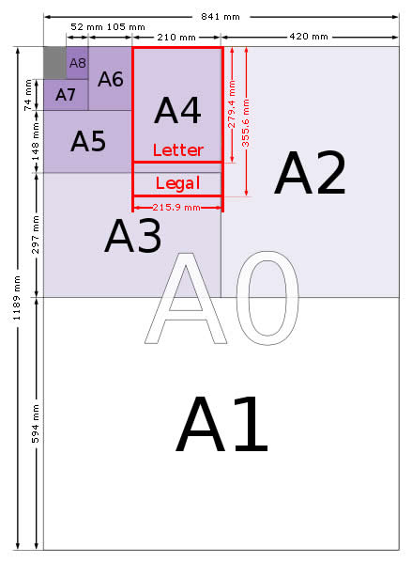If you were to print your map, you must consider the size in which it will be printed. You have to choose a specific paper size before adding elements to your map; otherwise you might print out a pixelated map that is hard to read. Also, depending on institutional standards and/or the data shape, you might have to change the page orientation from portrait to landscape, or vice versa. You can also set margins to avoid parts of the map being cut off when printed. [4]

|  |  |  |
| --- | --- | --- |
| **TYPE** | **SIZE (cm)** | **SIZE (in)** |
| **A3** | 29.3 x 42 | 11.7 x 16.5 |
| **A4** | 21 x 29.7 | 8.3 x 11.7 |
| **A5** | 14.8 x 21 | 5.8 x 8.3 |
| **B4 (JIS)** | 25 x 35.3 | 9.9 x 13.9 |
| **B5 (JIS)** | 17.6 x 25 | 6.9 x 9.8 |
| **Executive** | 17.8 x 25.4 | 7 x 10 |
| **Legal** (USA) | 21.6 x 27.9 | 8.5 x 10.9 |
| **Letter** (USA) | 21.6 x 35.6 | 8.5 x 14 |
| **Statement** | 19.7 x 27.3 | 7.7 x 10.7 |
| **Tabloid** | 27.9 x 43.2 | 11 x 17 |

|  |  |
| --- | --- |
| Labels | |
| In the introduction on cartographic design, having geographic reference information is important for users’ orientation in the map; it helps the user orient him or herself. One way to do this is with labels, which are also located in the properties for the shapefile.    Change  to  and then select the attribute that you want to be labeled, such as the name of the feature. You can edit the font, style, size, color, and transparency in the “Text” tab. Remember that cultural elements are sans serif, like Verdana. |  |
| You can also add a “halo” or buffer around the label’s letters for better visibility. If you click Apply and review the map you can see how your edits will look in the final map product. When you are done editing the labels, you can click OK and close the properties screen. |  |

Print Composer in QGIS

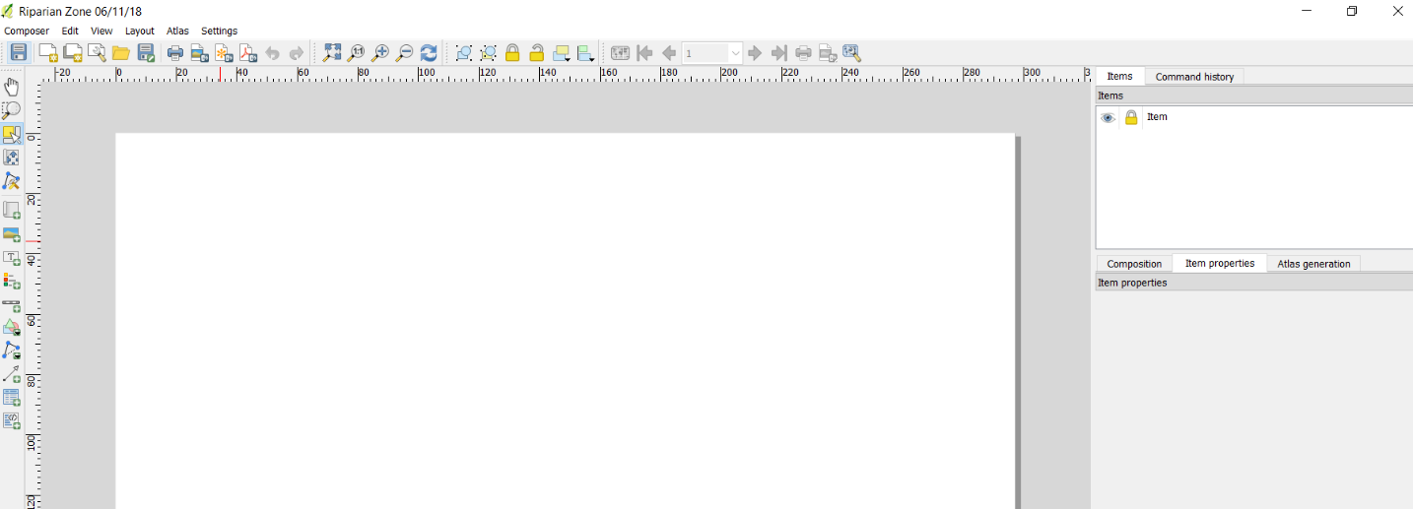

The print composer is the space where you begin creating your final map product. It is a separate interface within the QGIS desktop application/software.

|  |  |
| --- | --- |
| **Exercise 13. Print composer in QGIS.** | |
| To open the print composer, following route Menu Bar 🡪 Project 🡪 New Print Layout or with (Ctrl + P). A small interface will ask what name you would like to establish for the print layout. This does not automatically become the title of your map, so you can title the print composer something that lets you know what it represents. |  |

|  |  |  |
| --- | --- | --- |
| Page setup | | |
| In the pop-up screen you will have to go  Menu Bar 🡪 Layout 🡪 Page Setup    The sizes were explained in the cartographic design introduction. You can change the orientation and margins as well. Be aware that the margins are measured in inches. |  | |
| Elements of the map | | |
| The first step for adding elements to the composer is to Add new map. Click the tool icon and draw the rectangle for your map space. It will appear when you finish drawing the rectangle. | | ↓ |
| *You may need to move around elements and content. To do so use the following tools:* | | |
| Pan composer to move around the composer (not the data)  Select move item (elements of the map); this is the tool to use for changing the extent or position of an element  Move item content; panning within the new map, e.g. the data | | Zoom into/out of map; this does not zoom into or out of data)  Refresh view allows any changes made in the QGIS main interface to appear on the Print layout |
| The scale sometimes needs to be edited, in which case you would need to change the scale ratio. To make the scale “smaller” would require give it a larger denominator value. 1:1140000 is perfect for letter-sized paper for Rivne. A “larger” scale like 1:114000 would “zoom in” to Rivne oblast. An even smaller scale like 1:11400000 would “zoom out”. | |  |
| You can add a frame to the new map so that it has a border between map space and the white space in the margins. | |  |
| You can add grids to maps to show coordinate values, or simply to add aesthetics. You would have to add a new grid with the green plus button, which will create Grid 1. Then edit the different characteristics of the grid. Note that it will match the datum and projected coordinate system that we identified at the beginning of the module (WGS 84/UTM Zone 35N). You can change the intervals to add more or less grid lines, as well as change the style of the lines. For instance, it is good to have fewer grid lines or lighter grid lines so that they do not compete too strongly against the data and symbology in the graphical hierarchy. | |  |
| You can change the Frame style and thickness of the grid as well as the whether or not certain tick marks will appear on the final grid.    The coordinates are under “Draw coordinates,” which would need to be activated in order to edit the options. As you can see in the example, the Top and Right are disabled, which means only the Left and Bottom will show coordinate values. | |  |
| Rectangles, ellipses, and triangles can be added to the map. Rectangles often function well as background and frames for areas that include several different map elements. Draw one rectangle with a white background and a grey/black outline using the  Add shape tool. We will fill in this space with the scale, text, north arrow, and logos. | | 🡪 |
| If at any point you accidentally add an element and want to delete it, you simply need to select that element in the items list, go to Edit🡪Delete. | | 🡪 |
| Add image  There are many images that can be added to your final map. If you have an inset map to add, you would do so with the add image tool to browse for the image in your file folders. If you have a logo to add, again you can use the add image tool. | |  |
| The add image tool is also the correct way to add a north arrow. If you click on “Search directories” the software will search the program files for its svg files that were downloaded with the software application. There are also icons in here for cultural features, such as camping, bathrooms, and signage. | |  |
| Add new label (text)  The add new text tool is essential for adding the following map elements, such as projection and datum information:   1. Credits:      1. Notes:      1. Title and subtitles: | |  |
| Again, you can add shapes  or frame/background  to the text so that it is more legible. Just make sure that they are in the proper order under the items list. | |  |
| Scale  As you already know, scale is one of the mandatory map elements. It explains the scale that you modified when you added the map to the composer. It will appear on the final map so that users can understand how large of an area is being represented. In the Main Properties for the scale bar you want to make sure that the scale is for the active, main map – in this case, Map 1. You can change the tick marks and scale style, units, and segments to make it more aesthetically pleasing. To be consistent in your use of font, open Fonts and colors to edit the font type and color. | |  |
| Add new legend tool allows you to draw a legend space. You can activate Auto update to add all the map elements or just add them  or  delete them  individually.  You can also change the name  of a layer.  Adding a frame and background builds contrast with other map elements.  Remember to be consistent with fonts in your final map. | |  |
| Once you have completed your final map, you can save the composer.  If you are ready to publish the final map, you can do so as a PDF, SVG, and image.    When you choose your format, a notification will appear since we are using a basemap web map service (WMS). Click Close and save the final maps in the appropriate format and file folder. | |  |
| For the image export, it will ask you what resolution you want in dots per inch (dpi). The higher the dpi the better the resolution and the larger the file. Once you click Save the file will be saved into the folder file you identified previously. | |  |

Congratulations on successfully completing the workshop!

1. *Research Data Management* created by State University of New York College of Environmental Science and Forestry’s F. Franklin Moon Library Staff: **Bressler, A., Lafaver, Z., and Clemons, J. (2015)**
2. Source: https://www.dublincore.org/specifications/dublin-core/dcmi-terms/
3. Normalizing Census Data in ArcMap: Concepts and Roadmap. (2005). Esri Education Program. Retrieved from http://web.mit.edu/11.188/www/labs/lab3/normalize_arcgis.pdf.
4. Retrieved from http://www.officeneedsdirect.co.uk/tips-and-blog/item/what-are-a1-a2-a3-a4-a5-a6-a7-paper-sheet-sizes-dimensions-measurements.html